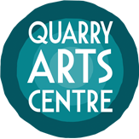
Open Ceramics Award 2019
The Northland Craft trust, in association with Ceramics NZ, is delighted to present the Quarry Arts Centre Open Ceramics award 2019. This is the second year for this annual event, after our 2018 award was such wonderful success. Our aim is to encourage and develop the continuation of excellence in ceramics in New Zealand, and to showcase the unique talents and techniques of New Zealand ceramic artists.
First Prize: $1000
Merit award: 2 year subscription to Art News New Zealand magazine.
People’s Choice award: 1 year membership to the Ceramics Association of NZ.

Important Dates
7th August – deadline for submissions. Send your completed entry form, images and dimensions of your work, and your entry fee.
14th August – We will notify all entrants regarding selection for exhibition.
28th August – Selected work must be delivered to us by 4pm
Friday 6th September – exhibition opening and winners announced
6th – 28th September: exhibition runs at the Yvonne Rust Gallery

Submissions
Each submission must be accompanied by an image of the work, the dimensions of the work, and the entry fee of $40 by Wednesday the 7th of August.
We will notify you to let you know if your work has been selected by 14th August.
Please email creative@quarryarts.org

Packaging and sending work
All work must be well protected and packaged securely. The Northland Craft Trust takes no responsibility for inadequately packaged work.
We will perform a condition report on all work as it is unpacked.

Details
Your work can be for sale, but it doesn’t have to be. Please be aware that the Quarry Arts Centre will deduct 30% from the retail price as commission. Please state the retail sale price.
If your work is the winning piece, it can still be available for sale.
We may accept more than one entry per person.
Judge to be announced at a later date.

To send us your entry form, you can:
- Email it to: creative@quarryarts.org
- Post it to: Quarry Arts Centre, 21 Selwyn Ave, Whangarei, 0110
- Drop it in to us in person at the above address.

Open Ceramics Award 2019 entry form

Name

Address

Email

Phone

Entry fee $40
Online payment
For online payments, please put the reference “OC Award”
Account name: Northland Craft Trust
Account number: 12-3115-0168720-00

Cash or eftpos at the Quarry office

Declaration
The artist’s signature here is confirmation that the entry work is the sole original work of the artist/s, and has not been previously exhibited.

Artist’s signature

Date

Your entry
You may enter up to 3 small works or 1 significant work. If you wish to submit more than this, you will need to complete another entry form and pay another entry fee.
Please be aware that The Quarry Arts Centre will deduct 30% from the retail price as commission. Your work does not have to be for sale. Please indicate with “NFS” (not for sale) in price column.

Title of Entry 1

Medium (eg. Raku, earthenware, stoneware, paperclay etc)

Dimensions (height, width, depth)

Retail price

Title of Entry 2

Medium

Dimensions

Retail price

Title of Entry 3

Medium

Dimensions

Retail price

Brief Artist Biography

Terms and Conditions of Entry
- All entries must be the original work of the entrant who executed it in concept and design. No work is to have been previously exhibited. Joint entries are permitted but all parties must be acknowledged on the entry form and all parties must agree to the terms and conditions.
- All styles of work are acceptable for entry providing the work is predominantly made from ceramic materials, or substantively addresses ceramic culture and practice.
- The curator and the judge reserve the right to reject entries at their discretion for the following reasons: if the deem it inappropriate for public display to our audience, if the work is not well executed, if the work is too big for display in our gallery, or if it is damaged.
- An entry fee of $40 must be included with the completed entry form. This entry fee is non-refundable.
- All entry forms are to be accompanied by an image of each piece of work being submitted.
- Entrants must complete and sign the official entry form.
- We must have the entry form, the fee and images of the work by August 7th at 4pm
- Late entries will not be accepted.
- There will be 1 judge - to be announced prior to the opening of the exhibition.
- The winner will be announced at the exhibition opening event. This is not an acquisitional award, the winning work will still be available to purchase if the artist had indicated on their entry form that it is for sale.
- The judge’s decision will be final and no correspondence will be entered into regarding the award, the exhibition or any decision made by the judge.
- Address for delivery of work is Open Ceramics Award, The Quarry Arts Centre, 21 Selwyn Ave, Whangarei 0110.
- Packaging must be clearly labelled with the entrant’s name.
- Freight to the gallery and transit insurance is the responsibility of the entrant.
- The Northland Craft Trust will return unsold work only to physical NZ addresses (no PO boxes) via Fastways courier.
- The artist will be liable for this which will be invoiced at cost to the artist.
- The Northland Craft Trust will take all possible care in returning the work in its original packaging; but will take no responsibility for any damage that may occur in transit.
- Northland Craft Trust reserves the right to photograph work for marketing and archival purposes.
- It is up to the entrant whether or not the work is for sale. The sale price, nominated by the entrant, needs to be full retail, and therefore needs to be inclusive of GST. The Northland Craft trust will take a commission of 30% off said retail price.
- Exhibition to be curated by Sally Spicer.

2018’s winners
Supreme Award

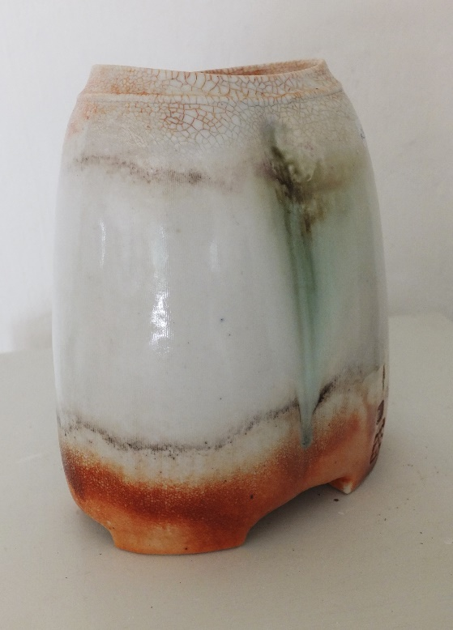

Greg Barron (Whangarei) “Oval Form”

2018 Merit Award Winners

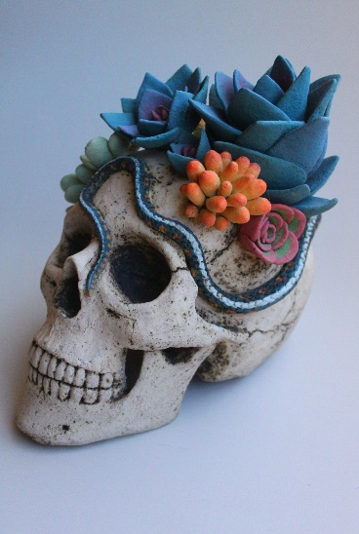
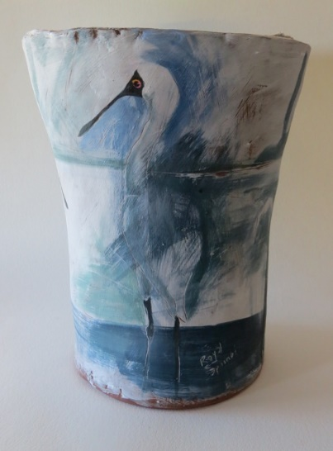

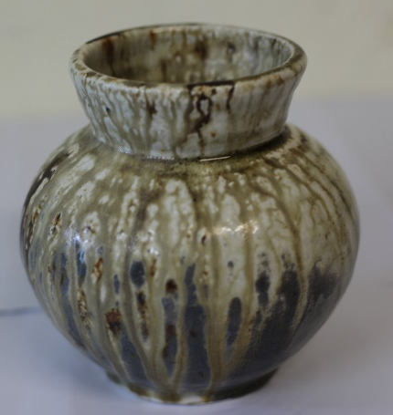

Dave Huffman (Whangarei)
“Flame Washed Coin Jar”
Cammie Blaisdell (Nelson)
“Transitions”
Lynda Harris (Kerikeri)
“Spoonbills”

